VACUUM CLEANER PROBLEM

Aim
To write a Python program to simulate the Vacuum Cleaner Problem in Artificial Intelligence.

Objective
- To simulate the working of a vacuum cleaner agent.
- To clean all dirty rooms.
- To demonstrate a simple goal-based AI agent.

Algorithm
- Start the program.
- Define the status of Room A and Room B (Clean/Dirty).
- Set the initial location of the vacuum cleaner.
- If the current room is dirty, clean it.
- Move to the other room.
- Repeat the cleaning process.
- Display the final status of both rooms.
- Stop the program.

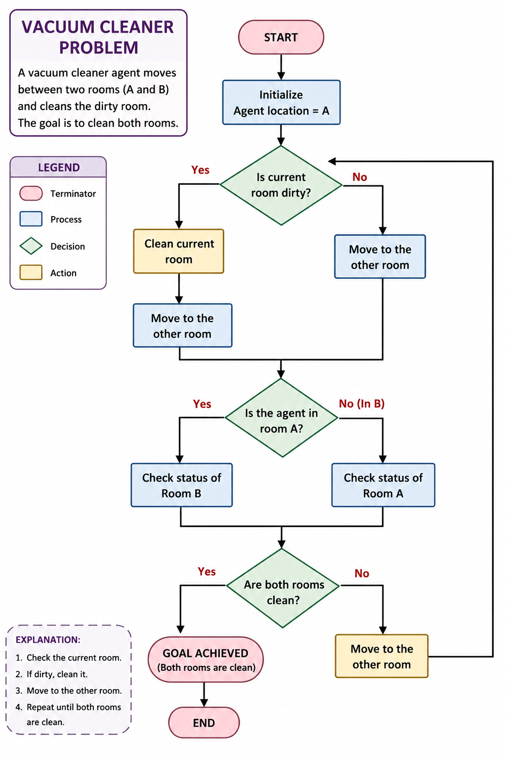
SOURCE CODE

# Vacuum Cleaner Problem

rooms = {"A": "Dirty", "B": "Dirty"}

for room in rooms:
print("Vacuum is in Room", room)

if rooms[room] == "Dirty":
print("Cleaning Room", room)
rooms[room] = "Clean"
else:
print("Room", room, "is already Clean")

print("\nFinal Room Status:")
for room in rooms:
print(room, ":", rooms[room ])

OUTPUT

